Project Documentation
University of Energy and Natural Resources, Suyani
Department of Computer Science and Informatics
Computer Vision Project.

Project Title: QR CODE/BARCODE SCANNER
Date: 2021-03-23
Project Manager(s): Dr. Benjamin Wayori
Key Project Team Members: Peacemaker Nana Kwesi Otoo, Emmanuel, JEFF
Tools & Libraries : Python, Jupyter IDE, Pyzbar and Open-CV.

Phase 1: Initiation
Project Proposal:
A barcode is a machine-readable, parallel-lined strip of data that can be used to display a variety of data. Retailers have traditionally used a barcode scanner to keep track of inventory and speed up data entry. Because of their widespread use in the commercial and industrial sectors, barcode scanning technologies have tended to be producer-centric, concentrating on increasing stock management reliability, precision, and productivity. We, on the other hand, want to develop a consumer-focused application. This app will double like a personal shopper, allowing the user to transfer products to an online catalogue or "wish list" for later purchase. This submission could also be emailed with browser integration.

Phase 2: Planning
Project Management Plan:
Our project has three main goals. The first goal is to replicate ZBar Bar Code Reader which is an open source software suite for reading bar codes from various sources, such as video streams, image files and raw intensity sensors. It supports EAN-13/UPC-A, UPC-E, EAN-8, Code 128, Code 39, Interleaved 2 of 5 and QR Code. These are the Python bindings for the library. The ZBar package contains pyzbar for encoding and decoding QR codes and Barcodes.
Milestones include configuring the on-board camera and installing image manipulation and barcode decoding libraries such as Open CV . Our second goal is to decode the barcode images in real-time, quickly and efficiently. This involves improving the image decoding algorithms and choosing efficient image manipulation and barcode libraries.
Our final goal is to scan and decode any qr/bar code image of any sort using the python libraries and displays the result to the user.
There are many different barcode types that exist for many different purposes. We can split these into 1D and 2D barcodes. 1D barcodes are what most people think barcodes are: columns of varying width lines that are imprinted on the back of products. Within the 1D barcode realm we have: EAN-13/UPC-A, Code 128, Code 39, EAN-8 etc. 1D barcodes are space inefficient, the barcode gets longer as more data is encoded and grows horizontally. Thus, 2D barcodes were invented to encode data not just horizontally, but also vertically in order to save space. [5] Within the 2D barcode realm we have: Data-matrix, QR code, EZ code, Smart code, etc. Each type of barcode is called a symbology, and there is a corresponding standard that defines the symbol and how to decode and encode the symbol.
1D barcodes are mostly used when space isn't an issue and messages are short. They are cheaper since the technology to decode them is easier, which is why they are more commonplace than 2D barcodes. Barcodes aren’t much cheaper than employing another technology, such as RFID. RFID requires purchase of tags, whereas barcode technology requires just inking costs. Thus from a cost point of view, it makes sense to use barcodes.
Additionally, barcodes are already widely available in the marketplace. Since our main use case was to be able to decode qr-code, we decided to focus on a 1D barcode reader/scanner. Currently, UPC labels are located on the back of most consumer products whereas 2D barcodes are not as readily available.

Phase 3: Execution
The mode of operation our project can be organized into eight main process steps:
- Importing the libraries we will use for the project.
$ from pyzbar import pyzbar # for the encoding and decoding
$ import cv2 #for the image manipulation
- # load the input image
image = cv2.imread('./qr_code.png')
- # find the qr-codes in the image and decode each of the qr-codes
barcodes = pyzbar.decode(image)
- # loop over the detected barcodes and extract the bounding box location of the qr-code and draw the bounding box surrounding the barcode on the image

for barcode in barcodes:
(x, y, w, h) = barcode.rect
cv2.rectangle(image, (x, y), (x + w, y + h), (0, 0, 255), 2)

- # the barcode data is a bytes object so if we want to draw it on our output image, we need to convert it to a string first:
barcodeData = barcode("utf-8")
barcodeType = barcode
- # draw the barcode data and barcode type on the image
text = "{} ({})".format(barcodeData, barcodeType)
cv2.putText(image, text, (x, y - 10), cv2.FONT_HERSHEY_SIMPLEX, 0.5, (0, 0, 255), 2)

- # print the barcode type and data to the terminal
print("[INFO] Found {} Image: {}".format(barcodeType, barcodeData))

- # show the output image
cv2.imshow("QR code", image)
cv2.waitKey(0)
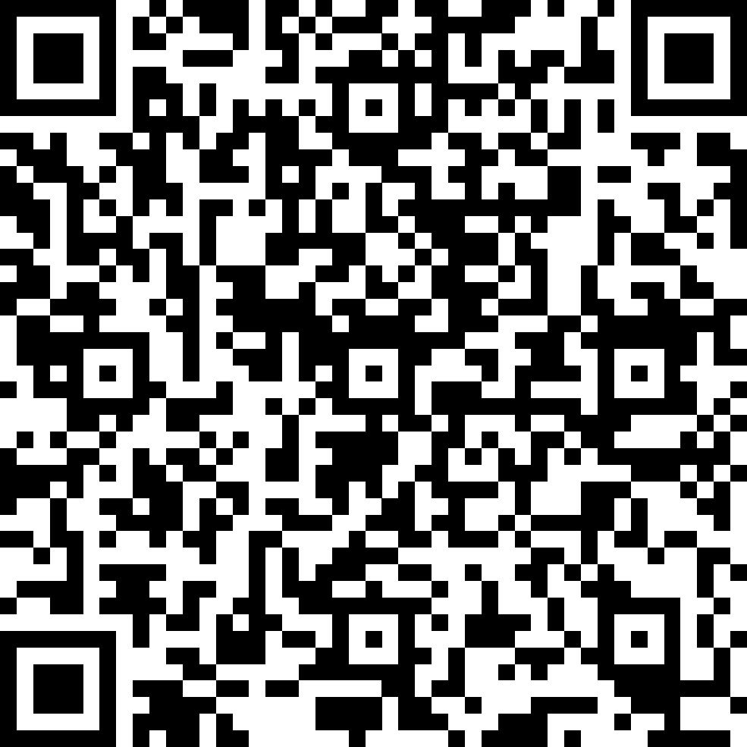
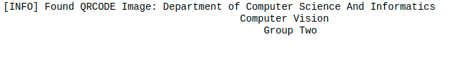

QR-code image The results

Phase 4: Conclusion
The barcode scanner works very close to how we expected. Because the provided camera has neither autofocus nor flash, it was often difficult to determine the exact cause of problems. However, after extensive testing we were able to produce a working scanner with good results. Thanks to efficient image conversion and decoding processes, the entire process runs predictably within reasonable time constraints; roughly a few seconds.
As far as resources are concerned, waste is kept low thanks to our pipelined data processing approach. Although decoding often takes up the majority of the process, the time it takes is usually constant. Therefore, the network connection can be considered the major bottleneck since it may produce uncontrollable results. Barcode decoding with mobile devices is definitely possible with the correct implementation. Yet in practice, results are dependent on the quality of the camera as well as the speed of the network connection.

References
1. Zebra. http://zebra.sourceforge.net/
2. Zxing. http://code.google.com/p/zxing/
3. Rigal, Daniel. Barcode. http://en.wikipedia.org/wiki/Barcod.
4. Information Technology—Automatic Identification and Data Capture Techniques—QR Code 2005 Bar Code Symbology, ISO/IEC 18004, Int'l Organization for Standardization, 2006.
5. Understanding 2D Symbologies: Detailed Information on Barcodes, Japan Automatic Identification Systems Assoc., 2004.
6. T.-D. Han et al., Machine Readable Code Image and Method of Encoding and Decoding the Same, US Patent 7,020,327, US Patent and Trademark Office, 2006.
7. Ihmig, M. 2005. Porting Linux to Intel's Glencoe Platform. Web site: http://www.cs.cmu.edu/~rtmach/mainstone/glencoe.pdf.
8. LINKS. http://links.sourceforge.net/
9. John's Java Imaging Processing Library. http://code.google.com/p/jjil/w/list
10. ImageMagick. http://www.imagemagick.org/script/index.

